How to Add Linked Complex Orders

Select the patient needing the complex orders > Select medication > right click > Select the type of linked order you would like to create: Exclusive, Linked, or Simultaneous.
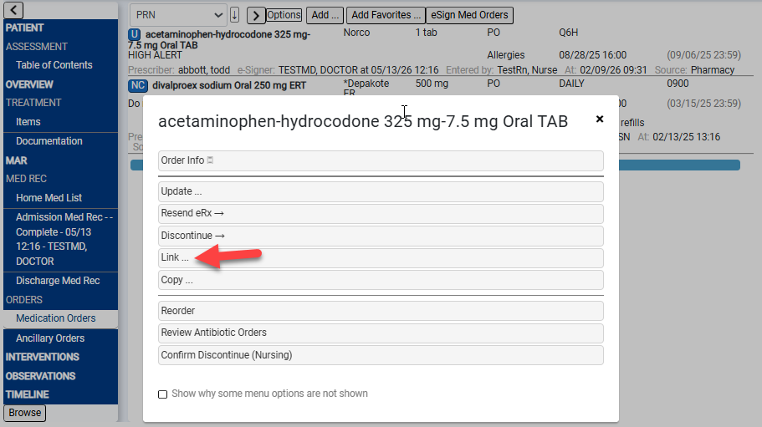
The order box pops up to select an order to Add Complex Order and click Okay.
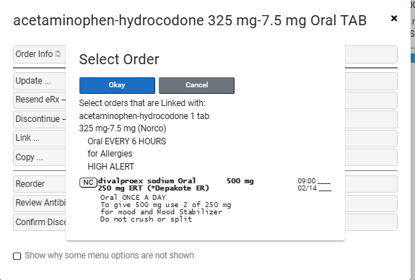
After the dispense windows are addressed, the orders will be displayed with an orange box to the left of the description indicating the type of link (L, E, S).

